**Understanding and Predicting Video Rank on YouTube’s Trending Tab**

By: Louis Weisz

**Abstract**

By analyzing publicly available data pulled from the YouTube Data API, I create a predictive model that determines whether a given topical video will land on the YouTube trending tab based upon its initial performance, and a secondary model that predicts approximately where it will rank. I also analyze recent and historical trends within the videos that have been on the tab, in order to dispel claims that the tab is rigged, biased, or otherwise inconsistent, and to fortify my predictions.

**Introduction**

YouTube, in just over 10 years has become the poster child for “New Media” -- and the Trending tab is its front page. With 96% of 18 - 24-year-olds using the platform, YouTube commands the attention of effectively all of Gen Z – and with that attention comes influence (Cooper, 2019) As of 2016, Google said that 68% of all YouTube users watched YouTube to make a purchase decision (Google, 2017).

The fairness of YouTube’s “Trending” tab, also known as “Trending”, has been a contentious topic ever since its inception in 2015. Several prominent creators have expressed major concerns with the feature, arguing (among other things) that the trending tab is an uneven playing field, and often claiming that it gives an unfair advantage to traditional media companies & personalities. Some have also argued that YouTube censors certain creators who make controversial content, blocking their videos from appearing on trending, while apparently allowing content from traditional media outlets that cover the same topics.

In this case, “traditional media” usually refers to companies or individuals who became known for their work through an outlet other than YouTube, like famous actors or popular TV channels. Because youtube is a corporation it would be legal for youtube to be doing any of these things, however in the modern era social media sites like YouTube serve as forums for public discourse.

Because manual curation of the trending tab would likely introduce bias into the system, it would be ethically questionable for YouTube, especially since YouTube claims that the goal of Trending is to surface videos that “capture the breadth of what’s happening on YouTube and in the world” (Google, 2019).

My goal by researching trending is to answer several questions about the tab, and to determine what factors determine a video’s likelihood to trend. While I don’t have direct access to the algorithm -- YouTube is intentionally vague about the specifics of the Trending algorithm, in order to avoid abuse of the system -- we can learn a lot about how the algorithm functions by looking at it’s output. Firstly, does the Trending tab appear to be manually curated? Can any of the allegations of bias, censorship, or unfair play be confirmed or denied?

If it appears that these claims aren’t accurate, then can we determine what makes a video trend? And if we can, can we predict the characteristics of future trending videos? Can we predict whether a given video will land on Trending, based upon its initial performance?

While much of the research done about YouTube thus far has been done at the video level, such as the 2018 study “Beyond Views” which shows that video engagement is predictable even when video popularity is not(Wu, Rizoiu, and Xie, 2018), my research looks at YouTube on the platform level. Rather than trying to predict how any random video will perform, my goal is to predict the output of the trending tab itself, to understand and explain the performance of topical videos relative to one another.

One of the best analyses of YouTube’s Trending tab specifically comes from the YouTube channel Coffee Break, in the form of a video where Stephen (the channel’s creator) discusses the results of his research into the trending tab (Coffee Break, 2019). Similarly, Dr. Derek Muller from the channel Veritasium made a video explaining the current state of the YouTube algorithm at large -- through the lens of what made one of his videos take off (Muller, 2019).

    The common finding in this research is that the metric YouTube values most is Click Through Rate (CTR) (Coffee Break, 2019) (Muller, 2019). CTR is the amount of clicks your particular video gets per time somebody looks at it. A higher CTR results in a higher view count -- but not just proportionally higher, exponentially higher (Muller, 2019). YouTube wants to recommend videos that lots of people are clicking, so high CTR videos consistently get promoted across the platform (Coffee Break, 2019).

    I think one of the biggest problems with Stephen’s research is that he uses data from 2017-18 as the basis for his findings. While I intend to use the same base dataset, I also want to test these findings against more recent data and see if the trends persist. Another consideration is that Stephen’s research focuses on the impacts that the trending algorithm has on creators, rather than on the algorithm itself. He argues that because the algorithm itself is a black box, it’s not useful to investigate what makes the algorithm itself tick -- and I agree. YouTube has internal metrics that are invisible or inaccessible to end users, which they are likely using in order to automatically curate the tab. However, with the right analysis, we can still get a pretty clear picture of what attributes a video needs in order to Trend.

**DATA:**

To perform my analysis, I relied on two datasets. One is a historical dataset collected by another researcher that covers a 7-month period from 2017-2018, and the other is a dataset that I pulled myself directly from the YouTube data API. While the historical dataset made API calls daily, I opted to make API calls hourly, in order to increase the granularity of the data. The new data covers a one-month period from mid-October 2019 to mid-November 2019. YouTube says that the video rankings on trending are updated approximately every 15 minutes (support.google.com, 2019) so an hourly pull of data has the potential to offer a more accurate view of the data without causing the file sizes to be larger than what my computer can reasonably handle. Both sets of data collected data on the same metrics, across 10 countries, with my dataset including a few additional metrics (like a video’s current trending rank). My analysis, however, focuses on only US data.

This dataset covers only videos that appeared on the trending tab, and tracks them only while they were trending (or “charting”, a category I define later). When I reference the “past 100 videos’ view median” later in this paper, that is data that I scraped later, and this hourly data is not available – understandably, as this would give us more insight that YouTube is likely comfortable with analysts accessing.

My calls to the YouTube Data API were made hourly using PythonAnywhere for automation. I worked primarily in Jupyter Notebook, using python’s Pandas module to clean and manipulate my data. Many of my explorative visuals were created in Seaborn, while the visuals used for my predictive models were created in R using ggplot. While the dataset requires extensive cleaning and manipulation to be able to draw useful results, the trade-off is that the sheer amount of information gives the potential for deeper understanding, and more accurate predictions.

**Methods**

To analyze this data, I began by looking at the first two questions I ask in the introduction.

1. Does the Trending tab appear to be manually curated?
2. Are the allegations of bias, censorship, and unfair play plausible or not?

Without the answer to these questions, any attempt to understand what makes a video trend or to predict the characteristics of future trending videos would be senseless, since it would be based on clearly biased data.

I started by looking at the historical data, and the analysis done by Steven from Coffee Break. Historically it has been argued that that traditional media channels are getting an advantage in the trending rankings, and Figure 1 does seem to potentially back that up.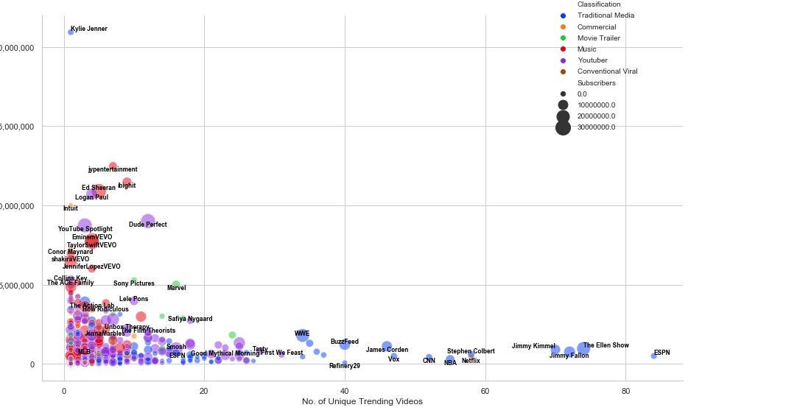 Looking at the modern data, however, in Figure 2 we don’t see the same trends. 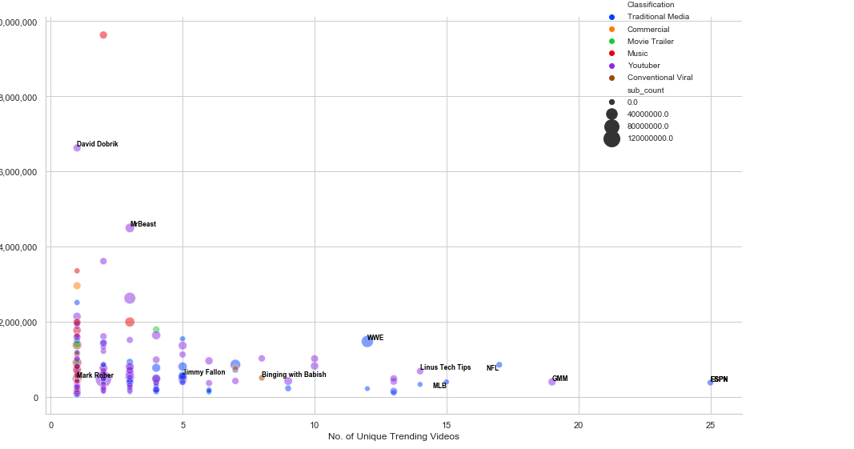

Average Views

20,000,000

15,000,000

10,000,000

5,000,000

**Fig. 1**

**Fig. 2**

Average Views

10,000,000

8,000,000

6,000,000

4,000,000

2,000,000

The idea is that these graphs show a particular channel’s “barrier to trending” (Coffee Break, 2019). By looking at the average view counts of the videos that successfully Trend for a particular channel, it gives us an idea of how well a video from a given channel has to perform in order to rank on Trending. Both figures 1 and 2 approximate a channel’s subscriber count in terms of bubble size. The color corresponds to what kind of media entity is represented by the channel (traditional media, music, youtuber, etc). On the x-axis, we see the total number of trending videos that a channel has had, and on the y-axis we see the average number of views a video from that channel had when it first landed on the trending tab.

To clarify the difference between a YouTuber and Traditional Media: in this case, we’re referring to YouTubers as people who got their fame/notoriety on the YouTube platform itself. Examples include Linus Tech Tips (Linus Media Group), PewDiePie, MrBeast, and David Dobrik. Traditional Media, by contrast, refers to celebrities or media companies that did not grow on YouTube, but got their fame beforehand by other means. Examples include Steven Colbert, Will Smith, CBS News, and Vox Media.

While it's true that from a "youtuber" perspective it seems like ESPN might be getting an unfair advantage ("why does the big traditional media platform get a boost?"), from an algorithmic perspective that theory just doesn't hold up. ESPN is a popular network, with numerous employees, posting multiple times a day and covering a topic that a lot of people are interested in (i.e. sports). The fact that they post multiple times every day on current, relevant topics means that they are likely to garner a very broad audience, which means that they will likely trend more often.

I wanted a more objective measure of this, so I made a new set of data that compares, on a per-channel basis, mean views of videos that Trend vs the median of the past 100 videos posted by that channel. I chose to use median as the comparison metric because it decreases the influence of outliers, whereas mean was appropriate for Trending videos because most videos that were on trending performed similarly to each other. I then split the channels into two categories, either Traditional Media or Youtuber.

In Table 1, I show analysis of the aggregate of these two categories by median.

**Table 1**

|  |  |  |
| --- | --- | --- |
|  | Typical Video: Median Views | Trending Video: Median Views |
| Youtuber | 1,453,130 | 1,523,222 |
| Traditional Media | 121,777 | 643,213 |

Looking at this we see that while videos by Youtubers that land on Trending tend to perform similarly to their typical content, videos by Traditional Media companies that land on Trending tend to perform a staggering 4-5x better than usual.

For a different look at this, Fig. 3 and Fig. 4 visualize the data on a per-channel basis for the top 50 most frequently Trending channels. Looking at those graphs you can see the same trend on a per-channel basis. This isn’t just an overall average for youtubers vs traditional media, it’s true for each individual channel. This is important because if you simply look across all traditional media channels you don’t account for the possibility of a small subset of consistently trending channel biasing the mean/median for the set as a whole. These more detailed graphs address that issue by showing that this phenomenon happens for individual channels, rather than just as an average across YouTube.

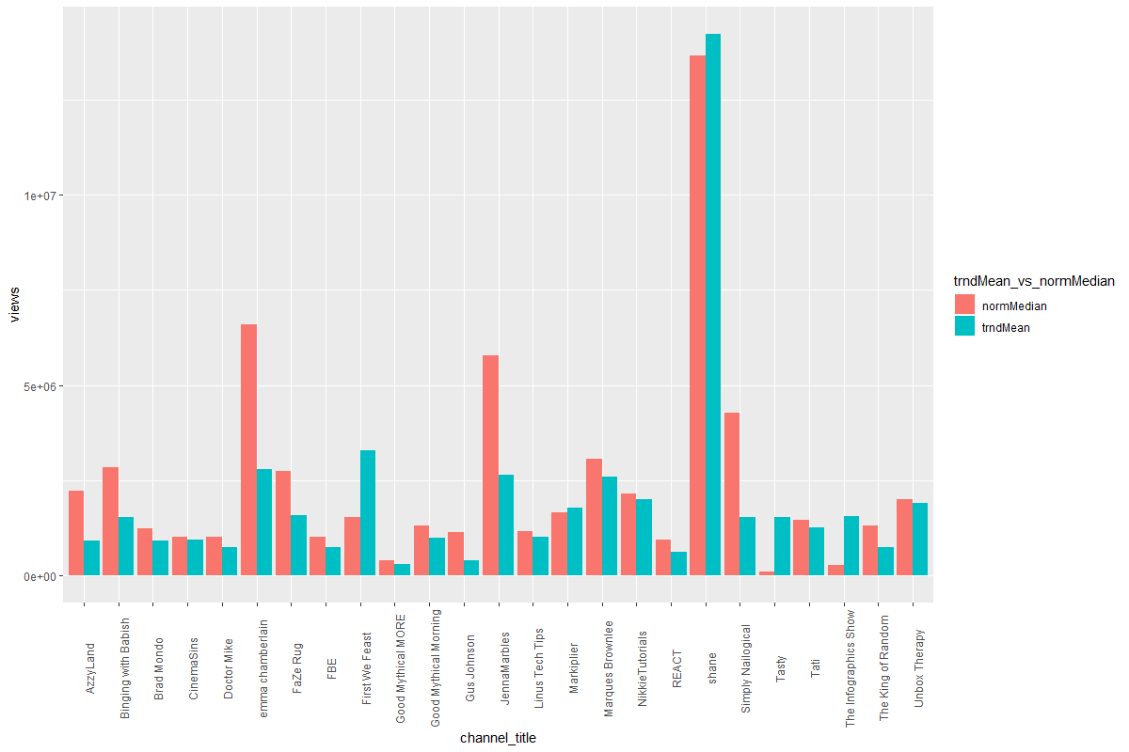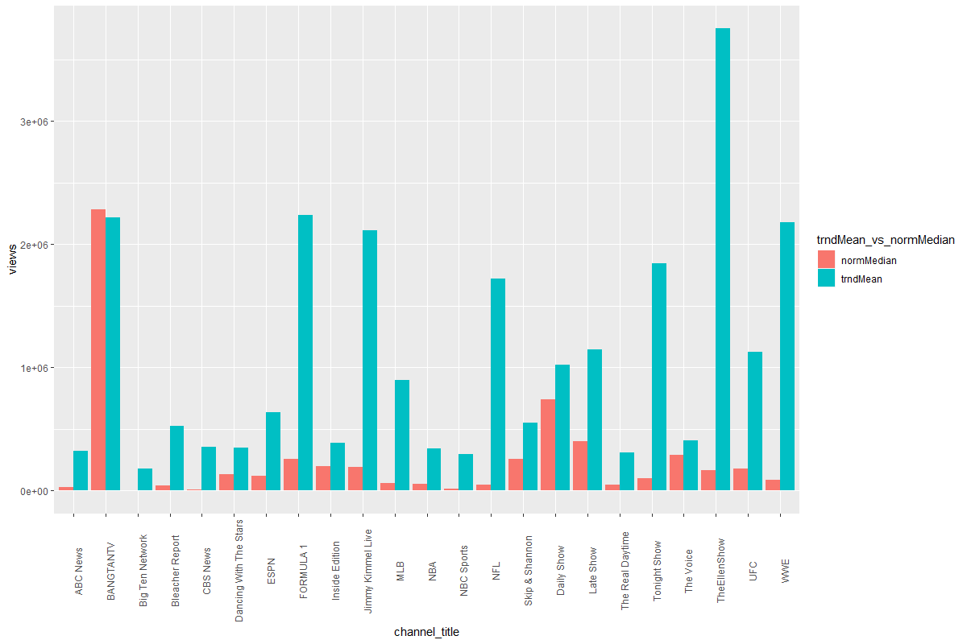

**Fig. 4 – Traditional Media Views Comparison**

**Fig. 3 – Youtuber Views Comparison**

The reality here is that we can't see all the back-end stats -- we can't see where viewers are coming from – but we can still get a good idea of what’s going on by comparing a channel's average video view count to the view counts of videos that trend. This is an imperfect metric, but it’s the best that we can do without access to individual channels’ private data.

What we find is that traditional media tends to put out content at a very rapid pace, but it doesn't tend to *land* with a youtube audience. Not every piece of content that they produce is something that everybody cares about, and I’m willing to bet you don’t consider yourself a “fan” of CBS News, for example, regardless of how much of their content you consume.

Youtubers, on the other hand, *tend* to put out content at a slower pace -- generally once a day at most -- however this content is usually well-targeted to their audience, so in general it does better. It appears that very few youtubers seem to see a substantial viewership boost from trending -- and this suggestion is substantiated by a recent comment by Linus from Linus Media Group. Linus noted that in one case, one of his videos managed to "trend" even while it was underperforming in terms of overall viewership (Linus Tech Tips, 2019).

Looking at these graphs side by side, it seems to suggest that it isn't the magnitude of viewership for a video that matters, but rather it's the breadth of that viewership. Youtubers tend to post videos that are well-targeted for their usual audience, resulting in a relatively consistent median view count. They can usually rely on their fans returning to watch their new content. By contrast, traditional media companies tend to post videos targeted at the general public rather than a specific niche. In other words, they don’t have hardcore “fanbases” for the most part – and even for those who do, like late-night comedians for example, their fans tend to watch their show on TV, not clips on YouTube. As a result, the only videos that trend for them are the videos that are topical and appealing to a wide audience.

Any channel's video should only really "trend" when it is being watched by a lot of viewers from outside that channel's main fanbase -- and this is true for any creator. According to YouTube, "Trending aims to surface videos that a wide range of viewers would find interesting" -- not just the most popular videos of a given day (YouTube, 2019). Because of this, "Trending" seems to relate to videos that are a notable mainstream success for a channel, i.e. videos that do better than usual with users outside a channel's core audience.

This also helps explain why “Trending” videos for Youtubers don’t perform exceptionally well when compared to their other videos. A video that is more appealing to a wider audience may be more likely to trend, and thus gain views that way, but it may also lose viewership overall since it is less directly targeted at that channel’s core audience. This likely isn’t seen when looking at traditional media outlets, since most of their videos are already targeted at a general audience.

Since trending does not appear to be manually curated, and the allegations of bias, censorship and unfair play do not appear to be plausible, I can make accurate predictions about trending videos based on their publicly available statistics.

**Understanding the Prediction Data**

When we look at trending, we discover that there are actually TWO sets of trending videos. There’s the main trending tab, which consists of the top 50 trending videos at any given time (typically visible by end users), and then there’s the full list of 200 videos that are retrieved when making an API call to scrape the trending list (not typically visible by end users). Each of those additional 150 videos falls into one of these two additional categories:

1. Videos that were recently trending, but have since fallen below rank #50
2. Videos that are likely to rank on Trending soon.

I’ve decided to refer to this subset of 150 videos as “charting” – they’re not quite relevant enough to be displayed on the main trending tab, but they almost are. i.e. they’re “on the charts”. Charting videos in this range are more commonly in category 1, likely because the statistics on videos that have been public for a longer time are less volatile and so they linger in this “charting” no-man’s-land for a longer time as their performance continues to slowly dwindle. It’s also possible that these videos are used for the “recently trending” feature, which is displayed below the main trending tab and features a handful of recently trending videos that are tailored to each user.

By contrast, videos in category #2 are early in their life. These videos are getting a lot of views and have constantly changing metrics for click-through-rate (the number of times a person clicked a video versus the number of times they saw a thumbnail for it) and view velocity (the number of views accumulated on a video over a given time period). As a result, these early-life videos experience exponential changes in viewership – and they are more likely to “debut” directly on the main Trending tab than to slowly climb the ranks of the “charts” – but land here when they don’t quite make the cut.

We can think of Trending overall like we think of popular music charts. “Trending” videos are like hit songs that become popular almost overnight, rapidly rising in airplay, and debuting highly on the billboard charts. Charting videos are not quite popular or relevant enough to be on trending, either because they haven’t had large enough growth (like most indie music), or because they’ve started to get stale after being out for a long time (like an overplayed pop song).

Understanding this allows us to make good predictions about where videos will debut and how videos will rank over time. We can also predict whether videos are likely currently Trending or merely Charting via classification based on similar predictors.

**Results**

I split the data I collected into a training and a test set. I then initially visualized the data by comparing debut trending rank to view count, with a line of a linear fit. (Figure 5)

We quickly see, however, that the data is nonlinear – instead, it actually resembles exponential decay, and so by scaling view count logarithmically we are able to get much better predictions and a much more accurate fit. (Figure 6)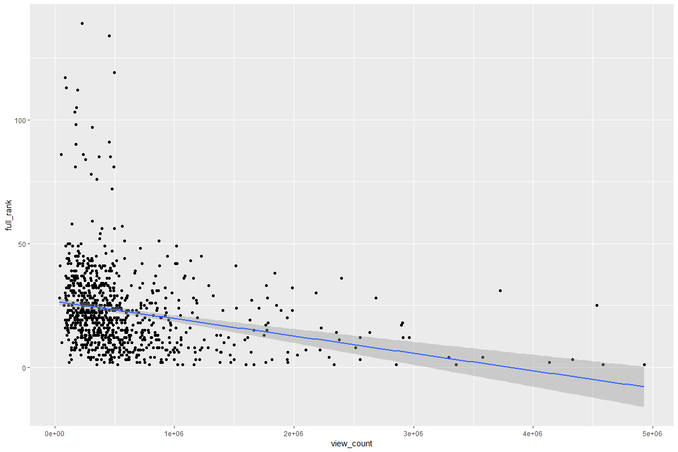

**Fig. 5 Video Debut Trending Rank vs View_Count**

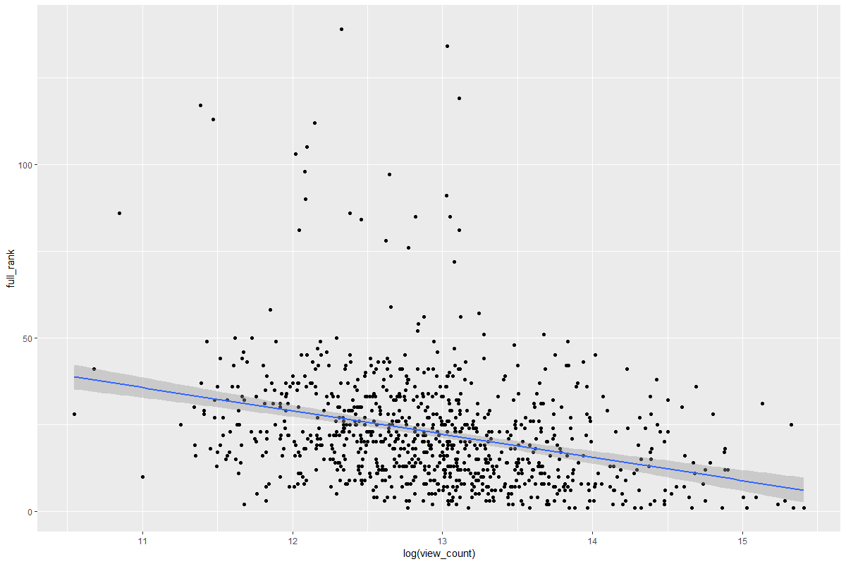

**Fig. 6 – Video Debut Trending Rank vs Log(View_Count)**

I initially intended to use linear models for my predictions, and even with this nonlinear data I was able to get good, consistent, accurate predictions my transforming my predictor variables as above.

The issue, rather, was that linear models don’t limit predictions to be within observed constraints. This meant that I was occasionally getting predictions of a trending rank greater than 200 or less than 0. As a result, I decided to go with a KNN approach. With the sheer amount of data available I’m able to effectively eliminate the influence of outliers, and the accuracy enhancements from using a KNN model are worth the computation time -- especially when predicting values near rank #1 or rank #200. For both models, the best results were obtained with a k-value of 5.

We can see this when we look at predictive accuracy. In a value range of 1-200, the model predicting debut rank on trending had an RMSE value of just under 12.92, with a chi-squared test returning a p-score of p<2.2e-16. In other words, it’s accuracy is significant, but our RMSE value is pretty high given a range of 200 values. It’s mostly just good enough to show that the ranking is algorithmic, not biased..

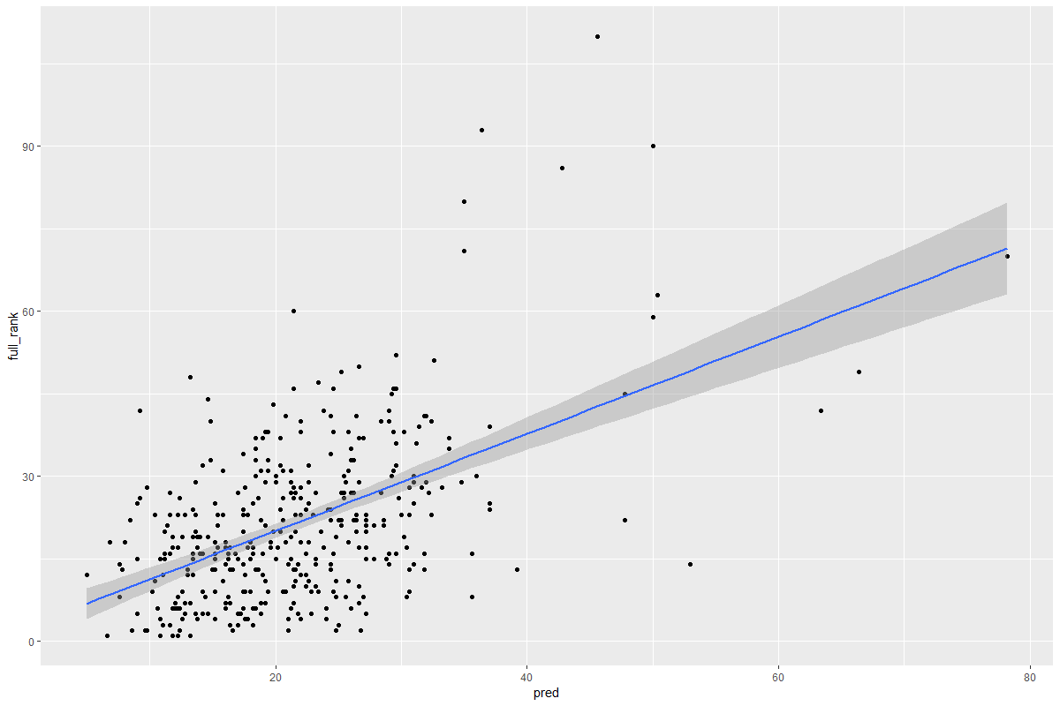

**Fig. 7 – Video Debut Trending Rank, KNN predictions.**

In addition, I felt it was important that the model makes predictions based on a small number of predictor variables, which are all easily available to any YouTube end-user. That way anybody can get an idea of whether a given video is likely to rank on trending. Specifically, it predicts rank based on a video’s: Current View count + View Velocity + Channel Subscriber Count + Time (in hours) since publishing.

My second model predicts current rank as an ongoing process. Rather than just looking at where a video is ranked when it debuts on trending, this model uses the full dataset to predict where a video is likely to rank at any given time after it is published. It is based on the same four predictor variables as the previous model.

In a value range of 1-200, the model predicting debut rank on trending had an RMSE value of just under 10.50, with a chi-squared test returning a p-score of p<2.2e-16. These models aren’t incredibly accurate, but our reasonable RMSE value and limited predictor variables ensure that it’s still generalizable rather than overfitted.

**Fig. 8 – Rolling Video Trending Rank, KNN predictions.**

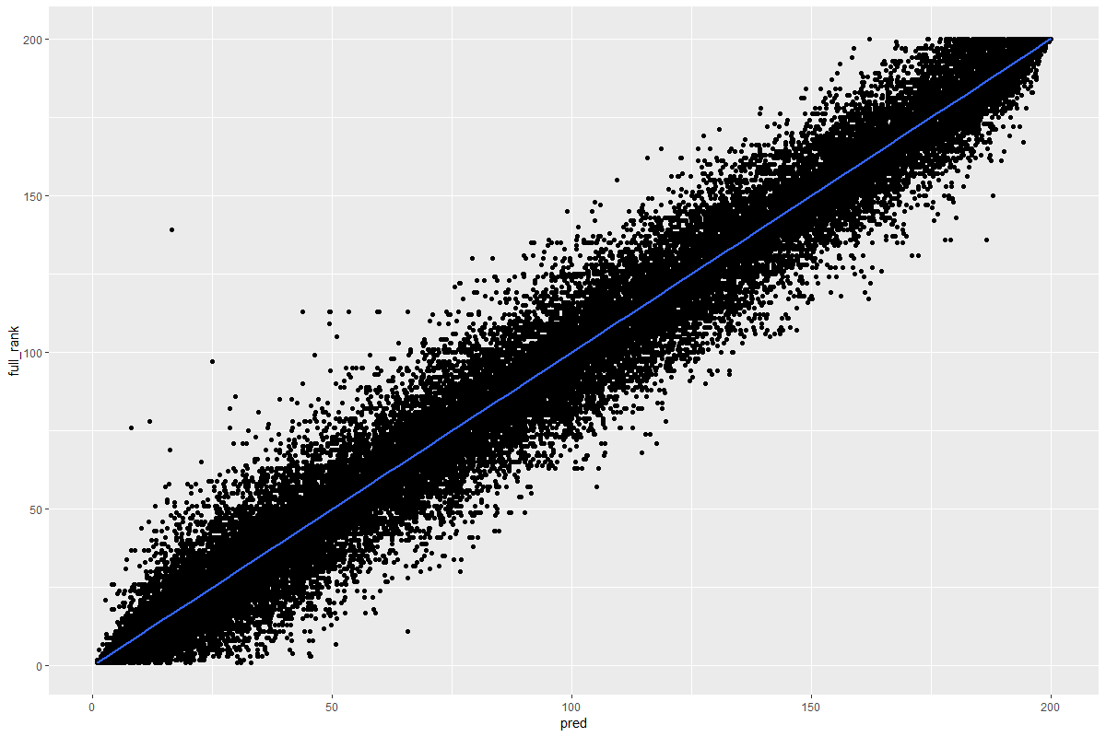

Again, we see a consistent distribution of predictions, all within a reasonable range of accuracy – and notably tapering at the extremes! One major benefit of using KNN was that it gave increasingly accurate predictions as we approach rank #1 on trending – which is especially relevant to this problem, as the top spots on trending are the most advantageous, since they receive the greatest number of user impressions. Thus, accuracy in this area is important.

Finally, I wanted to be able to predict merely whether a video is likely to be Trending at all, classifying videos as either Trending or Charting, based on similarly available stats as above.

Because most of the videos in the dataset are videos that are merely Charting rather than Trending, I trained a SMOTE dataset to balance these categories. Here, we see outstanding predictions.

Using a deep neural network to perform classifications, this model predicts a video’s trending status (Trending or Charting) with the following predictor variables: view count (scaled logarithmically) + Channel Subscriber Count + Time (in hours) since publishing.

With an accuracy score of .9376, p-value of p<2.2e-16, and a kappa score of .847, this model is able to make classification predictions on the test set with an outstanding degree of accuracy. This accuracy is reflected in the confusion matrix shown in Table 2, showing correct classification of over 90% of videos.

|  |  |  |
| --- | --- | --- |
| Reference  Prediction | Charting | Trending |
| Charting | 28505 | 822 |
| Trending | 1777 | 10570 |

**Table 2 – Confusion Matrix of Predictions by DNN model**

**Discussion & Conclusion**

Ultimately the main question here boils down to this: Do videos trend because they're widely popular, or do videos become widely popular *because* they hit Trending? In other words: is it rigged?

While it's difficult to be certain, I think that in general videos tend to hit trending because of widespread popularity -- and not the other way around. Based upon the analysis of the data, we can see the effect that trending has on video view count for various content publishers, whether they are traditional media sources or Youtubers. The most important predictor metrics for trending, according to the coefficients seen in the model, are time since the video was published, and view count. A full breakdown can be

What can this model do?

If we can assume that a video is sufficiently topical, we can use these methods to predict whether that video will trend. We also know what kinds of videos trend, based on our earlier exploration.

For example, if you were to feed this algorithm the initial performance metrics for a video about the new Apple AirPods Pro on the same day their AirPods announcement trailer was released (this announcement ranked #1 on trending for over 24 hours), I feel confident that this model could give a reasonable prediction about whether it will trend, and how highly it will rank. The same goes for Halloween costume videos released near Halloween, videos critiquing the new 2019 sonic trailer/redesign, and even humorous late-night commentary on current events.

YouTube’s stated goal with trending is to surface videos that are appealing to a wide range of viewers, and often that means videos that reference popular discourse. In the context of the three kinds of videos referenced above, Halloween is a popular nationwide cultural event, the sonic trailer was an important moment in internet culture, and late-night videos are an important commentary on current events, like elections.

Incidentally, this may explain the prevalence of late-night shows like Colbert in the historical dataset from 2017-18. Even a year after Donald Trump’s election, people were still talking about it constantly. Now, not nearly as much – people are likely more concerned with the next election. It will be interesting to see if this pattern repeats itself in the wake of the 2020 election.

What can’t this model do?

This model likely cannot take a truly random video, and accurately predict whether it will trend. A recently published, top performing video may be able to "fool" the algorithm because it does not account for topicality or relevance. For example, a long-awaited PC Build guide from a tech channel may skyrocket in views from that channel’s core audience – but it’s also likely to only appeal to tech fans. A popular video on a popular channel may surpass the initial performance of many trending videos and despite this, still not trend, due to a lack of broader relevance.

I believe that the relatively wide range in predicted rank values is due to an inability to see audience viewership or cultural relevance metrics. The work I’ve done shows that the tab is algorithmic (not rigged or hand-curated), but it does not *prove* that this “wide viewership” hypothesis is the explanation. Despite this, there are a number of examples that would support this hypothesis.

I think the best example of this is probably David Dobrik. Over the month that I collected data, only one video from him hit trending. Specifically it was one called "COCA COLA VS MENTOS INSIDE CAR". Currently, it has 11m views. A video posted two weeks ago by him, called "THIS WAS MY FIRST TIME MEETING HER!!" also has 11m views -- but did not trend, despite having the same amount of views in an even shorter time. Why is this the case? I think the titles say it all. Coke and Mentos is something everybody understands -- and the car variation is unique enough to pique most people's interest. It suggests a "disaster waiting to happen", something almost everybody finds funny, and so many people (even non-Dobrik fans) are likely to click on it. By contrast, the other video is specifically about David -- HIS first time meeting someone. If you don't care about David, you might not click on this video, since your interest in the video is based on your interest in Dobrik himself. However, if you *do* care about david, you might be *more* likely than usual to click this video -- which is likely why it still performed well, and arguably even better, overall.

This dataset that I created is based on videos that did trend, or that came close -- not a mix of similarly performing videos where some trended and others didn't. As a result, a video exhibiting similar performance may not trend if the algorithm deems it to be insufficiently topical or not interesting to a wide variety of users.

What’s Next?

I think the next step here is to dive into textual analysis of titles, tags, and possibly video descriptions or YouTube’s video caption transcripts. These have the potential to give a bigger picture of what a given video is truly about. Combined with ongoing analysis of YouTube trends and internet trends, this may grant the ability to predict whether ANY video will trend based on initial performance (rather than having to make the subjective assumption that a given video is topical and/or widely appealing).

**References:**

Bisht, M. (n.d.). Understanding Popularity Dynamics for YouTube Videos: An Interpretive Structural Modelling based Approach. Retrieved from <https://ieeexplore.ieee.org/abstract/document/8701274/figures#figures>

Choe, M. G., & Seo, D. W. (2018, December 12). How Long Will Your Videos Remain Popular? Empirical Study of the Impact of Video Features on YouTube Trending Using Deep Learning Methodologies. Retrieved from <https://link.springer.com/chapter/10.1007/978-3-030-22784-5_19>

J, M. (2019, June 3). Trending YouTube Video Statistics. Retrieved from <https://www.kaggle.com/datasnaek/youtube-new>

Naaman, M., & Berger, J. (n.d.). A Data-Driven Study of View Duration on YouTube. Retrieved from <https://www.aaai.org/ocs/index.php/ICWSM/ICWSM16/paper/viewPaper/13062>

Rober, M. (n.d.). Mark Rober. Retrieved from <https://www.youtube.com/channel/UCY1kMZp36IQSyNx_9h4mpCg/community?lb=Ugwb_LporVj2XukPJxd4AaABCQ>

Rui, L. T., Afif, Z. A., Saedudin, R. D. R., Mustapha, A., & Razali, N. (n.d.). A regression approach for prediction of Youtube views. Retrieved from <http://www.beei.org/index.php/EEI/article/view/1630/1232>

Wilson, L. (2019, April 12). Clickbait Works! The Secret to Getting Views with the YouTube Algorithm. Retrieved from <https://papers.ssrn.com/sol3/papers.cfm?abstract_id=3369353>

Yang, R. (n.d.). Video watch time and Comment Sentiment: Retrieved from <https://ieeexplore.ieee.org/abstract/document/7785813>

Coffee Break. (2019, May 21). What 40,000 Videos Tell Us About The Trending  
Tab. Retrieved from <https://www.youtube.com/watch?v=fDqBeXJ8Zx8>.

Muller, D. (2019, May 19). My Video Went Viral. Here's Why. Retrieved from <https://www.youtube.com/watch?v=fHsa9DqmId8>.

Park, M., Namaan, M., & Berger, J. (2016). A Data-Driven Study of View Duration on YouTube. Retrieved October 1, 2019, from <https://www.aaai.org/ocs/index.php/ICWSM/ICWSM16/paper/view/13062/12820>.

[Park](https://www.aaai.org/ocs/index.php/ICWSM/ICWSM16/paper/view/13062/12820)

Wu, S., Rizoiu, M.-A., & Xie, L. (2018). Beyond Views: Measuring and Predicting Engagement in Online Videos. Retrieved October 1, 2019, from <https://www.aaai.org/ocs/index.php/ICWSM/ICWSM18/paper/view/17892/17035>.

J, M. (2019, June 3). Trending YouTube Video Statistics. Retrieved from <https://www.kaggle.com/datasnaek/youtube-new>

Trending on YouTube. (Google, 2017). Retrieved from [https://web.archive.org/web/20170929072348/https://support.google.com/youtube/answer/7239739?hl=en](https://web.archive.org/web/20170929072348/https:/support.google.com/youtube/answer/7239739?hl=en).

Trending on YouTube - YouTube Help. (Google, 2019). Retrieved from <https://support.google.com/youtube/answer/7239739?hl=en>.

How Does Twitter Decide What Is Trending? (n.d.). Retrieved from

<https://rethinkmedia.org/blog/how-does-twitter-decide-what-trending>.

Cooper, P. (2019, November 6). 22 YouTube Stats That Matter to Marketers in 2019. Retrieved from <https://blog.hootsuite.com/youtube-stats-marketers/>.

Google. (2017). The Latest YouTube Stats on When, Where, and What People Watch. Retrieved from <https://www.thinkwithgoogle.com/data-collections/youtube-stats-video-consumption-trends/>.

Linus Media Group. (2019, November 1). *YouTube P-Score Drama – WAN Show November 1, 2019* [Video File]. Retrieved from <https://www.youtube.com/watch?v=rXz0veV1AuU&t=1766s>.

**Appendix**

All files and data used for this project are also available in this shared google drive folder:

<https://drive.google.com/drive/folders/17XTNXVeYqlIocqrJnHrdb7OCz-oacwaV?usp=sharing>